NEXTAG COMPANY

Saffiano Leather Coin Purse

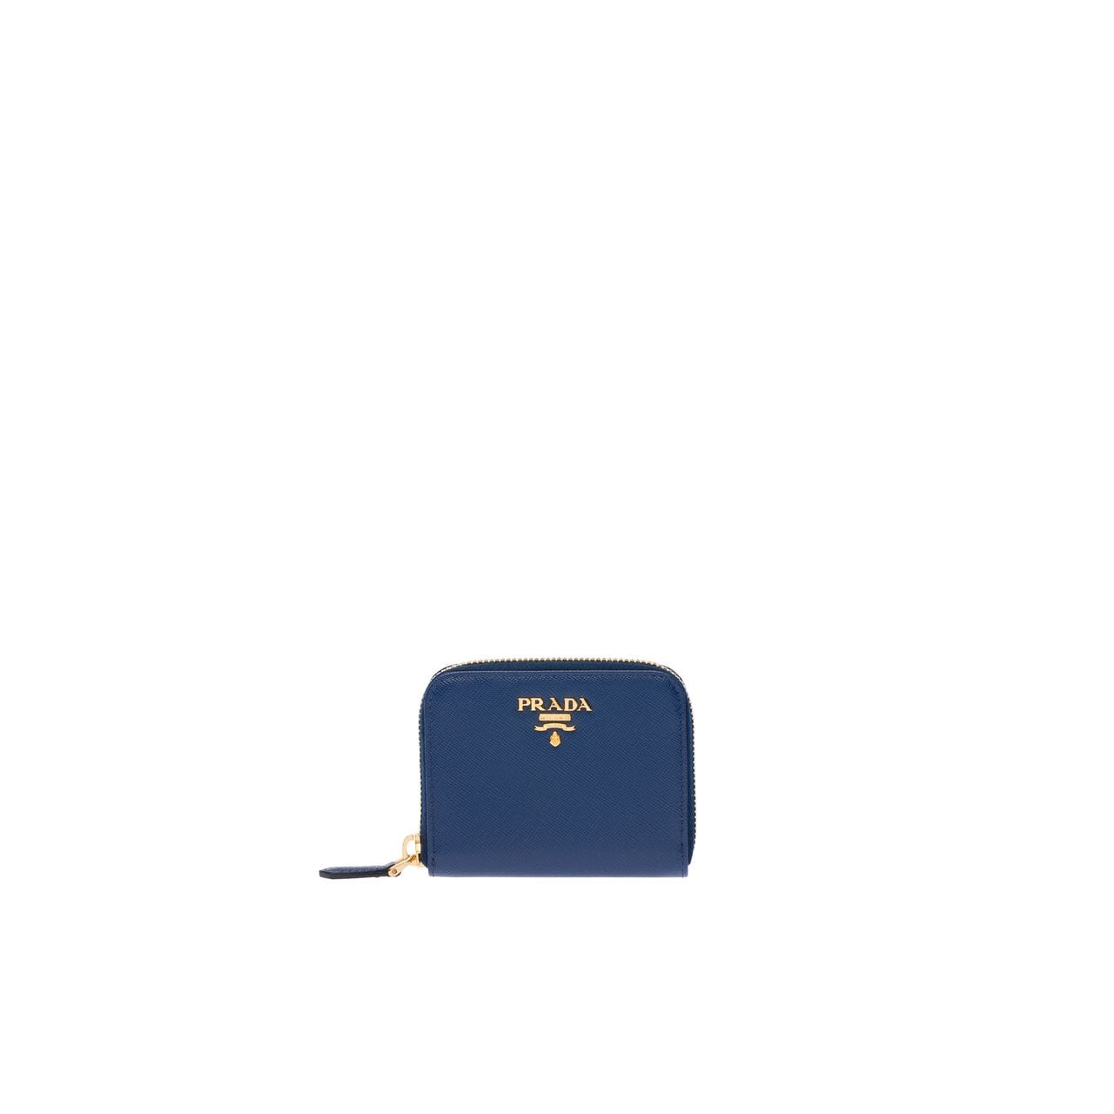

Style # 1MV204_2CDM_F0YQY

360 $

product details

Saffiano leather  
Three inside coin compartments  
Zipper closure  
8 cm height  
10 cm width